Rear axle model

# 1 System description

Model of the rear axle. The model includes the electrical machine and the converter associated, and the differential representing the transmission.

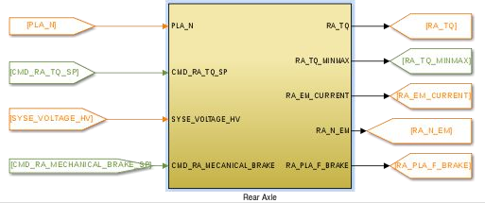

# 2 System organization

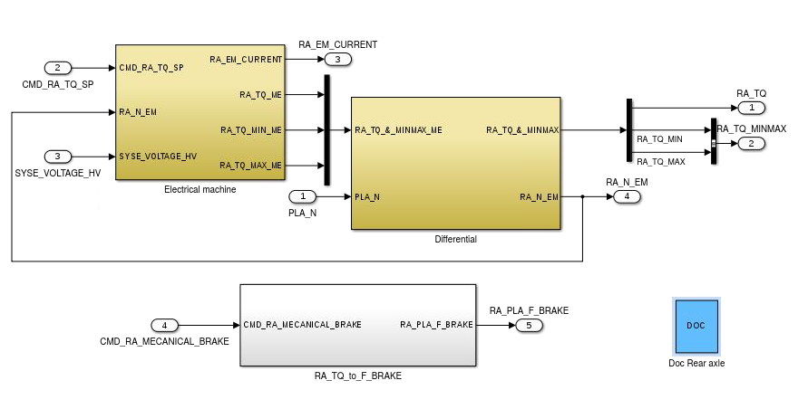

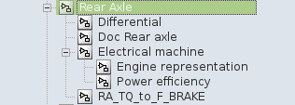

Model browser

# 3 Signals and parameters

## Inputs

|  |  |  |
| --- | --- | --- |
| Name | Description | Note |
| PLA_N | Wheel speed | In RPM |
| CMD_RA_TQ_SP | Torque set point for the electrical machine |  |
| CMD_RA_MECHANICAL_BRAKE_SP | Torque set point of mechanical brake ofrear axle | In N.m |
| SYSE_VOLTAGE_HV | Voltage on the DC power bus |  |

## Outputs

|  |  |  |  |
| --- | --- | --- | --- |
| Name | Description | Note | Destination |
| RA_TQ | Torque to wheel from the rear axle |  | Platform |
| RA_PLA_F_BRAKE | Force set point of mechanical brake ofrear axle | In N | Platform |
| RA_TQ_MINMAX | Minimum and maximum torque of the electrical machine | Bus signal | Command |
| RA_EM_CURRENT | Electrical machine requested current | - | Electrical system |
| RA_N_EM | Electrical machine shaft speed | In RPM | Electrical system |

## Parameters

### Native

|  |  |  |  |  |  |
| --- | --- | --- | --- | --- | --- |
| Name | Type | Unit | Description | Source | Linked to |
| ra_electrical_machine_efficiency | table | - | Electrical machine efficiency | Continental | ra_electrical_machine_torque; ra_electrical_machine_speed |
| ra_electrical_machine_speed | vector | RPM | Electrical machine speed input vector for table and vector | Continental | ra_electrical_machine_efficiency_modified; syse_em_in_power; ra_em_max_tq; ra_em_min_tq; syse_electrical_machine_torque_vs_power_speed_nneg; syse_electrical_machine_torque_vs_power_speed_nnpos |
| ra_electrical_machine_tau | var | s | Electrical machine time constant | Continental |  |
| ra_electrical_machine_torque | vector | Nm | Electrical machine torque input vector for efficency | Continental | ra_electrical_machine_efficiency_modified; ra_electrical_machine_speed |
| ra_em_max_tq | vector | Nm | Electrical machine maximum torque | Continental | ra_electrical_machine_speed |
| ra_em_min_tq | vector | Nm | Electrical machine minimum torque | Continental | ra_electrical_machine_speed |
| ra_differential_ratio | var | - | Rearaxledifferential ratio | Continental |  |
| ra_transmission_efficiency | var | - | Rearaxledifferentialefficiency | Continental |  |

### Inherited

|  |  |  |  |  |  |
| --- | --- | --- | --- | --- | --- |
| Name | Type | Unit | Description | Source | Linked to |
| pla_wheel_radius | var | m | Wheel radius (includes tire deformation) | BEI N7 2014 |  |

# 4 Subsystems description

Electrical machine:

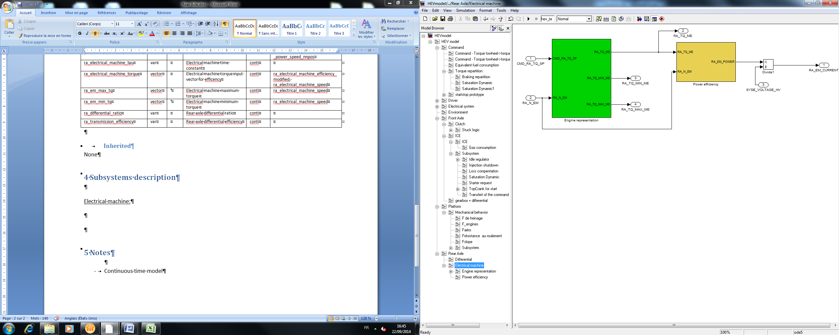

Two part model:

Engine representation: calculate the torque generated and the torque limits

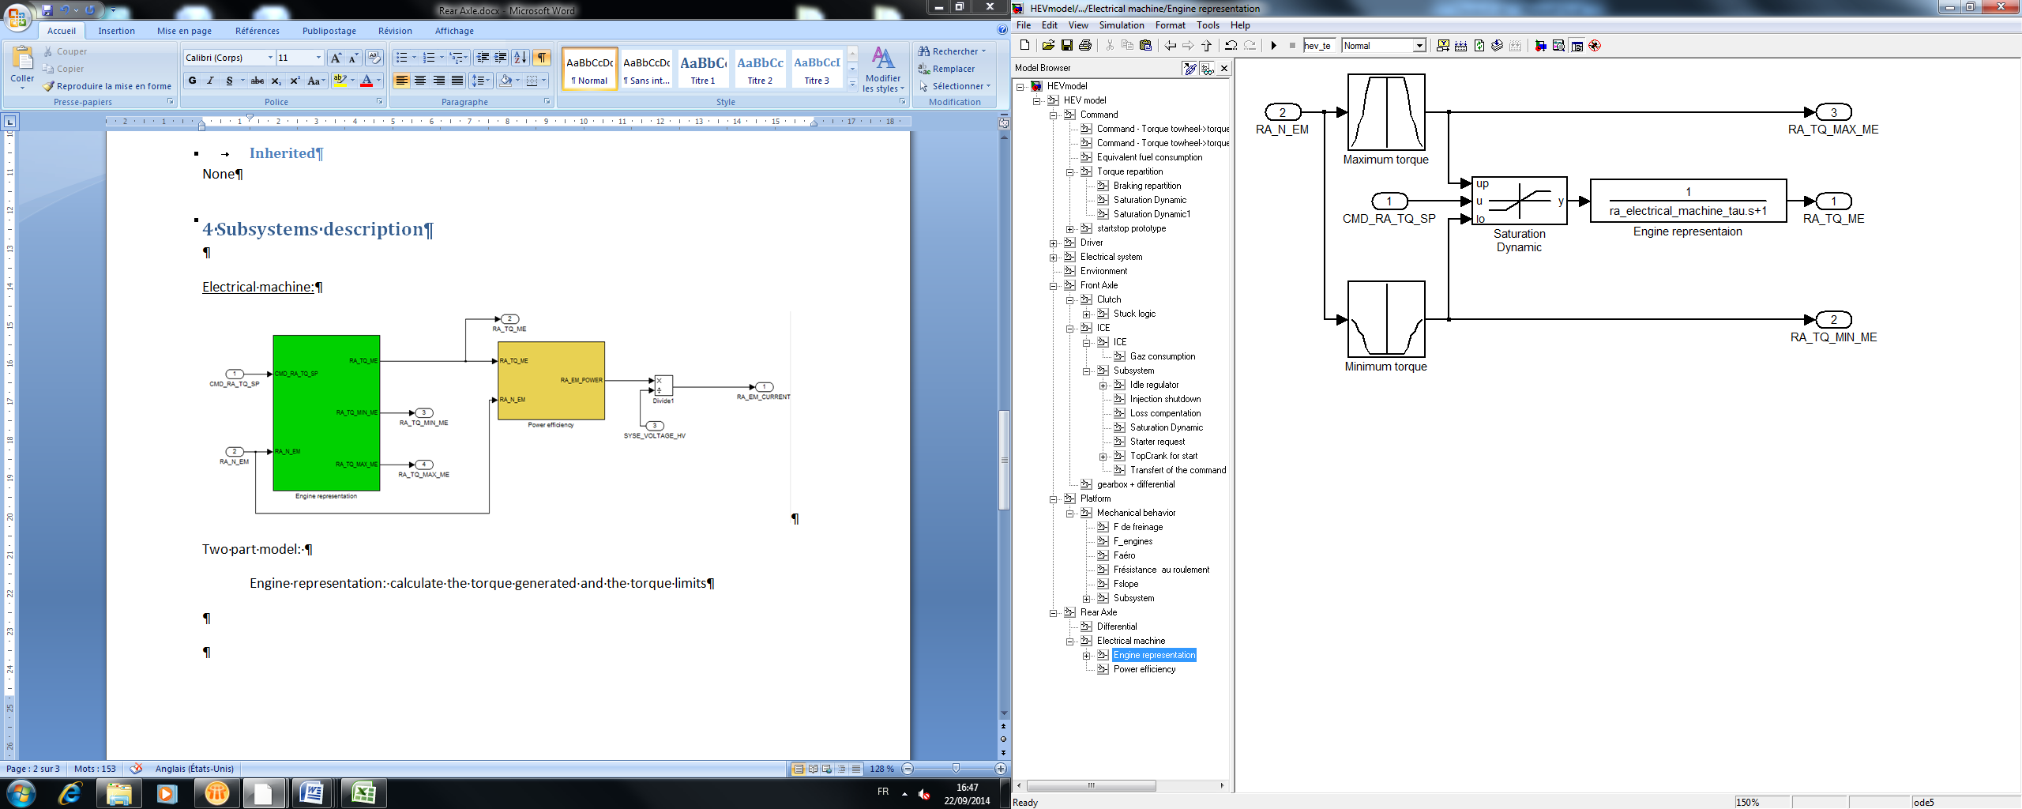

Power efficiency: determines the consumed electrical power.

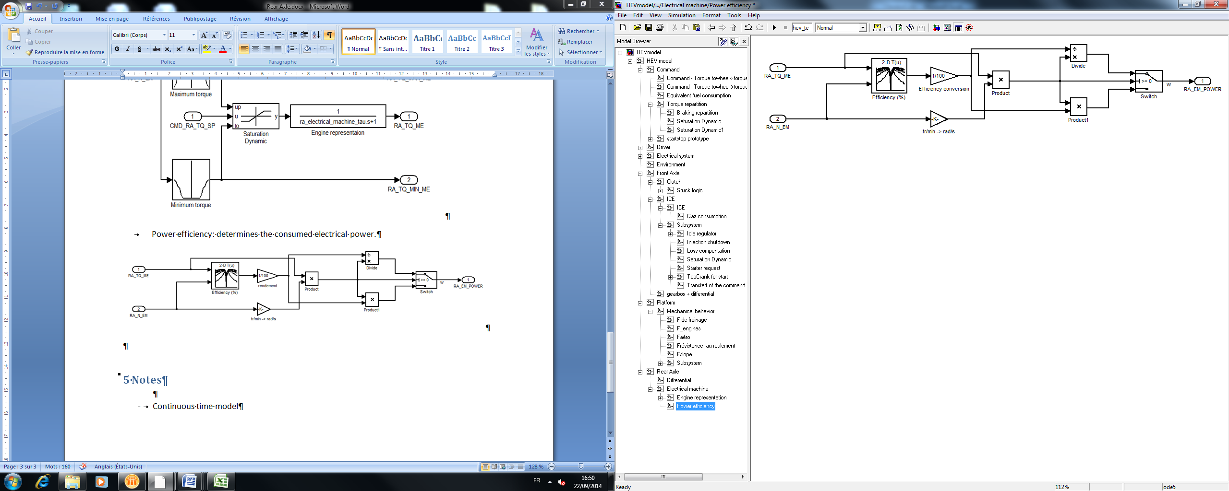

Differential

Conversion of the speed and torque between the engine and the wheel

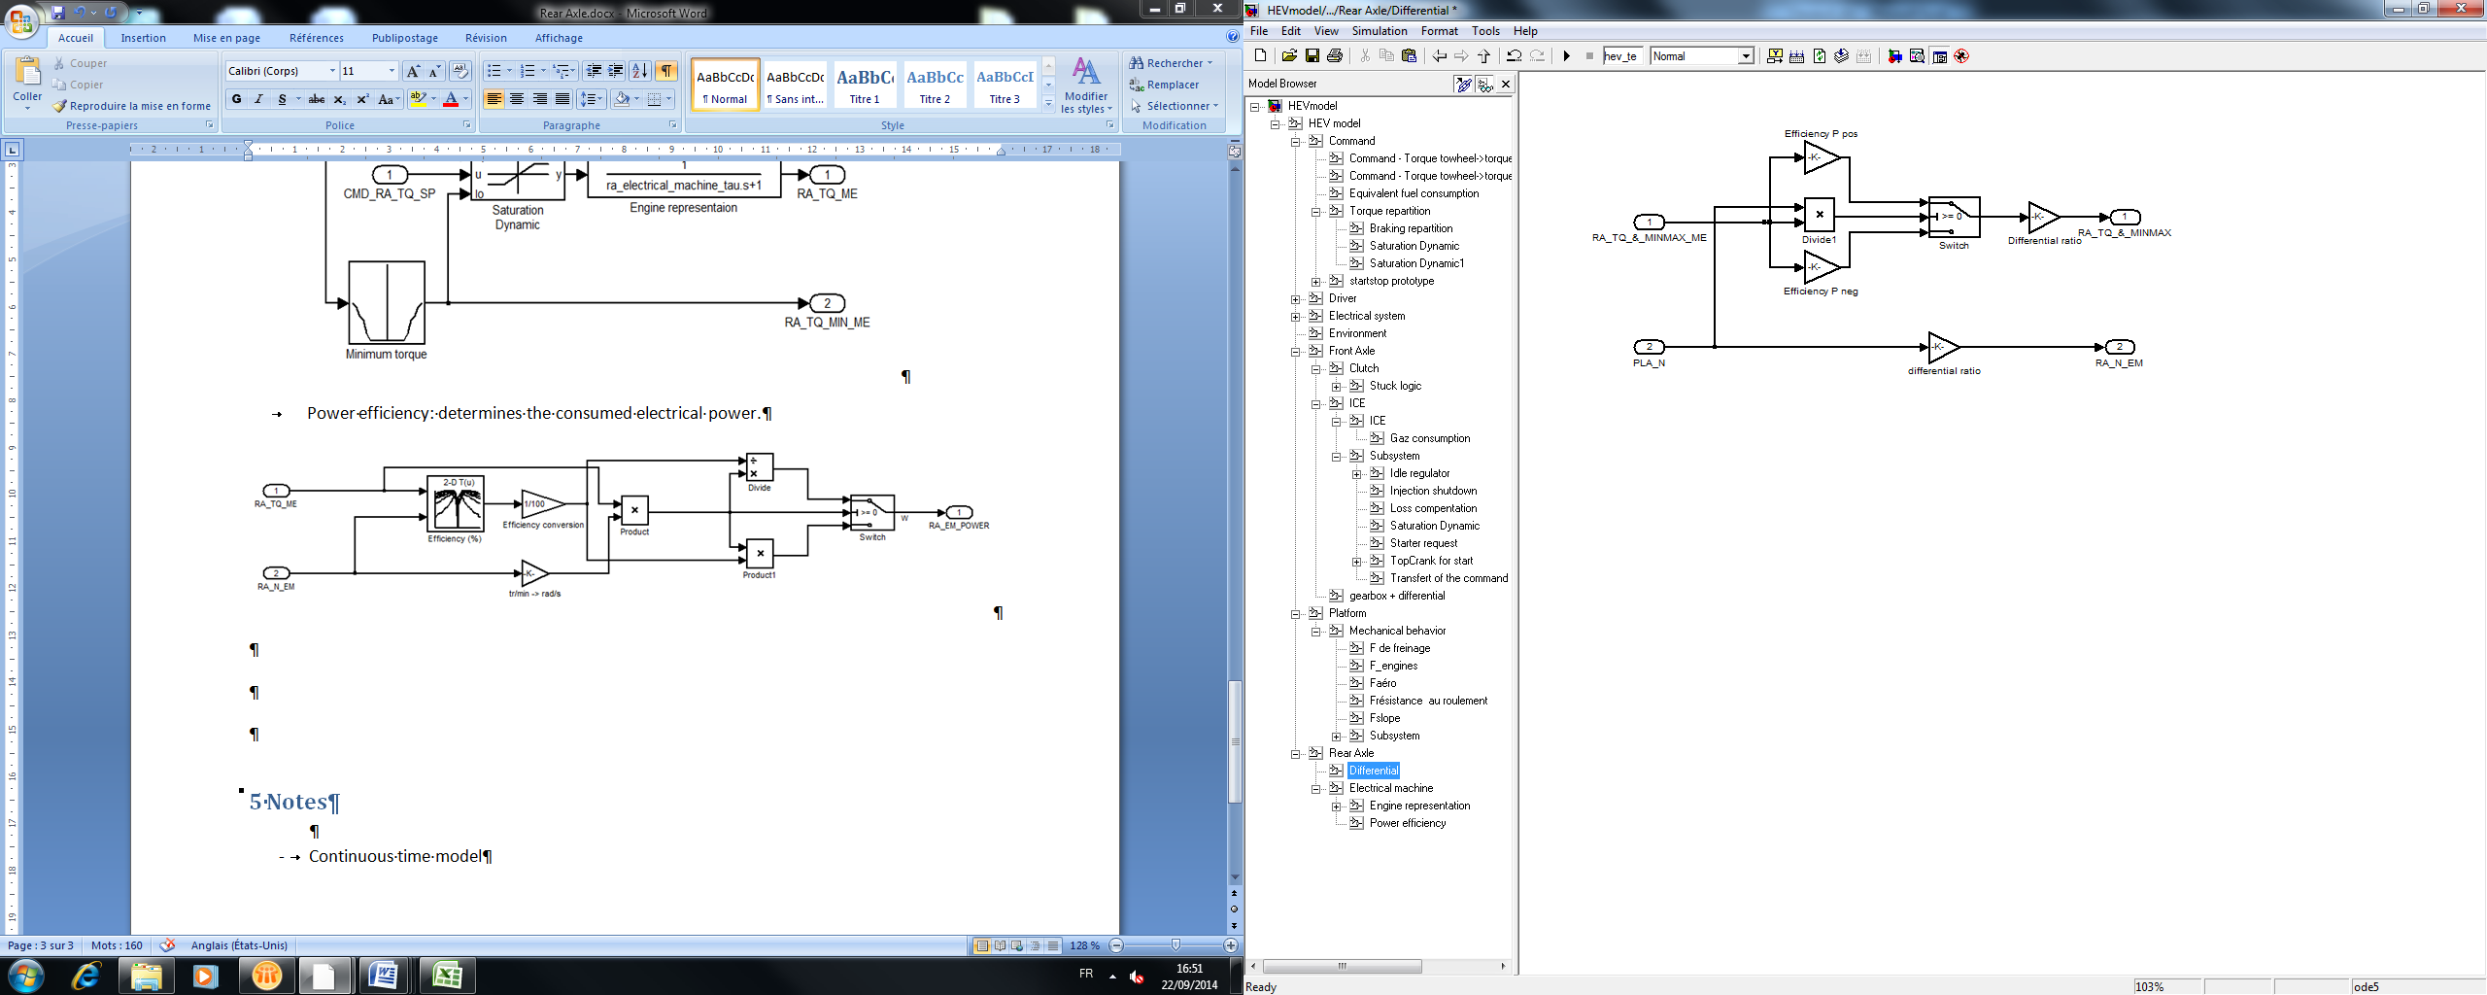

Braking Torque to force conversion

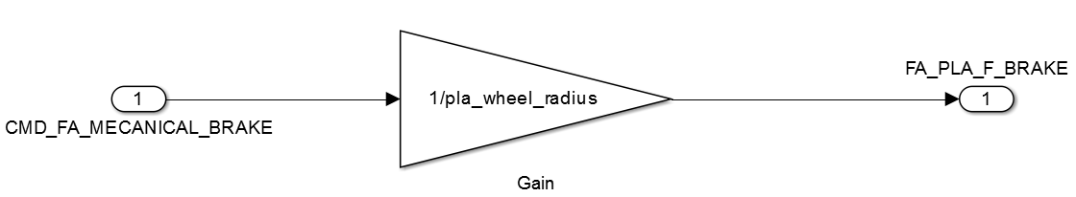Convert torque to wheel braking to force braking

# 5 Discrete Model

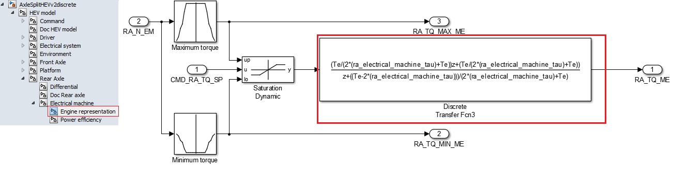

Same inputs, outputs and parameters. The only changes are in the red square.

See part 5 (“Discrete model”) of the document “HEV model” to know how are made the discrete blocs.